CURRICULUM VITAE
Teaching Staff
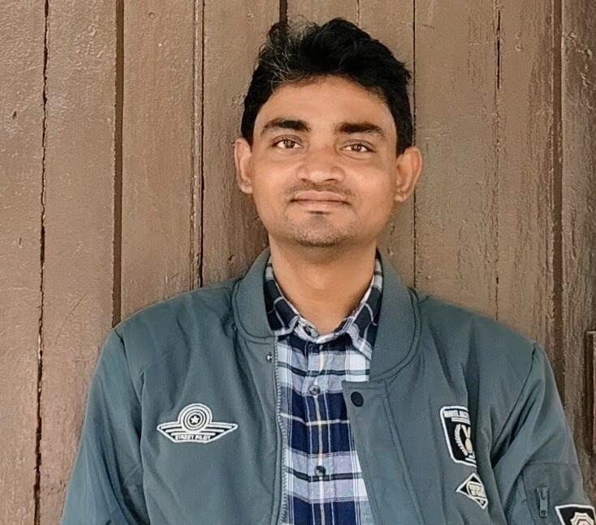
1. Department : History
2. Name (In Block Letter) : MRITUNJOY DUTTA
3. Designation : State Aided College Teacher, Category 1
4. Joining Date : 01/09/2018
5. Contact Number : 7001850189
6. Email id : mdutta@grsm.ac.in
7. Permanent Address : Ghoshpur, Keshpur, Paschim Medinipur,
West Bengal 721150
8. Present Address : House of Rintu Ghosh, Town Colony,
Tantigeria, Midnapore, Paschim Medinipur,
West Bengal 721102.
9. Qualification :

Degree | Name of Institution | Passing Year
P.G. | Vidyasagar University | 2014
M.Phil | Vidyasagar University | 2017
SET | WBCSC | 2017

10. Research Experience :
Name of the Post | Temporary/ Permanent/ on Contract Basis etc. | Name of Institute | Year of Joining | Year of Leaving | Duration of Research | Research Description
MPhil | Permanent | Vidyasagar University | 2015 | 2017 | 2 Years | Contagious Diseases Act O Beshyabrittir Niyantran: Kolkata o Sahartalite er Pravab
PhD | Permanent | Vidyasagar University | 31.01.2023 | Pursuing |  | The Making of Pharmacopoeia and its Impact on India: 1868-1930

11. Teaching Experience:
Guest Lecturer, Ghatal R.S. Mahavidyalaya, Dept. of History, 01.09.20218-31.12.2019.
SACT-I, Ghatal R.S. Mahavidyalaya, Dept. of History, Since 01.01.2020.
Guest Faculty, Vidyasagar University, CCAE, Dept. of History, Since 10.03.2025.
Academic Counsellor, NSOU, Dept. of History, Ghatal, Study Centre D-09, Since 21.12.2024.

12. Details of Publications:
- Unabinsha Shatabdir Dwitiyardhe Bharate Beshyabritti o Venereal Diseases: Samrajyabadi Vabadarsha. 2018, Samaj Jijnasa, Vol. 11, No. 1 & 2, Vidyasagar Centre for Social Sciences, Midnapore. ISSN 2321 158X (In Bengali)
- Unabinsha Shatabdir Dwitiyardhe Bharate Europiya Senabhahinir Swasthya Sochetanata o Beshyabrittir Niyantran: Prasanga Indian Contagious Diseases Act. 2018, Itihas o Sanskriti, Vol. 4, No. 3; Itihas, Samaj o Sanskriti, Paschimbanga Anchalik Itihas o Loksanskriti Charcha Kendra, Kolkata. ISSN 2394-5737 (In Bengali)
- Niyantran o Pratirodh: Kolkata o Shahartalite Indian Contagious Diseases Act ebang Ganika Samaj. 2019, Itihas Onusandhan 33, Paschimbanga Itihas Samsad. ISBN 978-81-939476-0-9 (In Bengali)
- Keeping ‘Cool’ in the Tropics: Army Health and Governance in Colonial India. 2025, Anudhyan, Vol. 10, Issue 1, ISSN- 2455-6319.
- Khirpai-er Mandir Sanskriti: Ekti Arthasamajik Bishleshon. 2025, Antorjatik Pathsala, Vol. XIV, Issue III & IV, 2025, ISSN- 2230-9594. (In Bengali)
- British Bharate Deshiya Osudh ebong Kanny Lall Dey (1831-1899). 2024, Itihas Anusandhan 37. Pachimbanga Itihas Samsad: Kolkata ISBN: 978-81-935519-7-4 (In Bengali)
- Jointly with Antara Bera, Kolkata o Sahartalite Plague, Paschatya Chikitsa Ebong Nursing Byabastha: Samajika Pratikriya (1896-1900). 2026, Itihas Anweshan 3, Garia Society for Studies of Marginal People: Kolkata, ISBN: 978-93-93490-56-8 (In Bengali)
- Bhāratiya Cikitsa Paddhatite Ayurveda Sastrer ‘abaksaya’ na ‘samanbaya’: Ekati Paryalochana. 2025, Taurean Publications: New Delhi ISBN: 9789347310928 (In Bengali)
13. Paper Presented In Conference
- ‘Prevention of Contagious Diseases and the control of Prostitution in Calcutta and its Suburbs’
Indian Council of Historical Research (ICHR) sponsored National Conference in the Department of History, Vidyasagar University, Paschim Medinipur, on “History of Medicine in Theory and Practice: Health Care in India” on 18 and 19 February 2020.
- ‘Navigating the Tropical Climate: Health and Governance of the Army in Colonial India’
In the International Seminar (Hybrid Mode) on Climate, Environment and Culture: The Historical Impact on Societies, held on 25th March 2025 at Vidyasagar University, Dept. of History, in collaboration with Eco-Lab Network, Nottingham Trent University, United Kingdom.
- ‘Khirpai-er Mandir Sanskriti: Ekti Arthasamajik Bishleshon’ (In Bengali)
In a One-Day International Seminar on “Society, Economy and Ecology in Colonial India: Issues and Perspectives”, organized by Dept. of History, Ghatal Rabindra Satabarsiki Mahavidyalaya, in collaboration with Paschimbanga Itihas Samsad, 23 June, 2023.
14. Academic Awards and Honours
 | Awarding Authority | Year | Description
Silver Medal | Vidyasagar University | 2012 | Stood second in order of merit among the successful candidates of B.A (Honours) examination in History of the year 2012 and awarded the University Silver Medal of the year at the convocation of the University held in 2015.
UGC Rank Holder Fellowship | University Grants Commission | 2012-2014 | Stood second in order of merit among successful candidates of B.A (Honours) Examination in History of the year 2012  in Vidyasagar University.

15. Workshops/Training/Academic Participation
- Participated in a 7-day workshop organized by the Department of History, Vidyasagar University In collaboration with Rajiv Gandhi National Institute of Youth Development (RGNIYD), Ministry of Youth Affairs & Sports, Govt. of India, 11–17 March 2022
- Participated One Day Research Scholars Orientation Programme, IQAC, Vidyasagar University, 27 June 2023.
- Participated in a 2-day workshop organized by the Critical Thinking and Writing Lab, Under JPN National Centre of Excellence in the Humanities Indian Institute of Technology Indore, 25–26 August 2025.
- Attended MASHA-MAEASaM GIS Workshop on Mapping Archaeological Heritage using GIS, 24 February 2026 (online).

