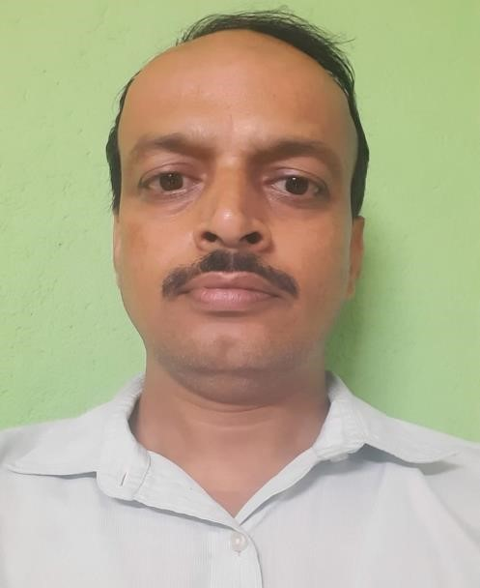

Department : Music

Designation :
SACT

Name :
Avijit

Bhunia


Date of Joining :
9/12/2009

Experience :
15

years

Mob : 9647477909

Gmail :
avijitbhunia27@gmail.com

/
abhunia@grsm.ac.in

Parmanent

Address :
vill

:
-

Kashiganja
,
po
:
-

Khirpai
,

Dist.:
-

Paschim

Medinipur
, PIN:
-

721232
CURRICULUM VITAE
Head Of The Department

M.A in H.C.M ( R.B.U)
M.A in
Rabindrasangeet

B.ED (M.D.U)

