BIO-DATA / CURRICULUM VITAE
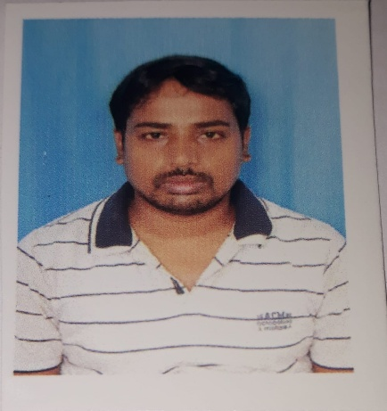
SUBHENDU NATH PATRA
Designation: State Aided College Teacher (SACT)
Department / Unit: National Service Scheme (NSS)
Institution: Ghatal Rabindra Satabarsiki Mahavidyalaya
Email: snpatra@grsm.ac.in
Contact Number: +91 7797325366
PERSONAL PROFILE & CONTACT DETAILS
- Village: Kalgang
- Post Office: Midnapore
- Police Station: Kotwali
- District: Paschim Medinipur
- Pin Code: 721101
- State: West Bengal, India
PROFESSIONAL SUMMARY
Dedicated and highly qualified academician in the field of Political Science, currently serving as a State Aided College Teacher (SACT). Possesses deep analytical insight into governance, state systems, and regional dynamics with a core academic specialization in South Asian socio-political structures. Alongside core teaching responsibilities, actively leads and coordinates community development frameworks as a core resource person for the National Service Scheme (NSS) and institutional Social Service wings. Successfully cleared the West Bengal State Eligibility Test (WBSET) in 2024, demonstrating a strong track record of academic competence, youth leadership, and a commitment to holistic higher education.
AREAS OF SPECIALIZATION & CORE EXPERTISE
- Academic Specialization: Society and Politics in South Asia (Regional geopolitics, state-building, cross-border dynamics, and democratic transitions).
- NSS & Community Development: Organizing special camping programs, field-based rural asset mapping, and executing grassroots social welfare interventions.
- Social Service & Public Outreach: Coordinating health awareness drives, blood donation camps, environmental cleanliness initiatives (Swachh Bharat campaigns), and community literacy programs.
- Youth Leadership & Civic Engagement: Mentoring undergraduate youth volunteers in social responsibility, disaster management orientation, and civic rights sensitization.
EDUCATIONAL QUALIFICATIONS & ELIGIBILITY
Examination / Credential | Board / University / Conducting Body | Specialization / Subject | Year of Passing
WBSET | West Bengal College Service Commission | Political Science | 2024
M.A. | Vidyasagar University | Political Science | 2013
B.A. (Honours) | Vidyasagar University | Political Science | 2011
Higher Secondary (12th) | WBCHSE | Humanities | 2008
Madhyamik Pariksha (10th) | WBBSE | General Subjects | 2006

PROFESSIONAL & EXTENSION EXPERIENCE
State Aided College Teacher (SACT)
- Academic Deliverables: Deliver lectures on diverse undergraduate modules including political ideologies, democratic governance, international relations, and South Asian political systems.
- NSS Unit Administration: Experience in NSS cell operations, organizing annual or special camps in adopted villages to address regional socio-economic challenges.
- Social Service Interventions: Supervise student-led community outreach, managing blood donation mobilization, health check-up camps, plantation drives, and awareness rallies (e.g., dengue prevention, anti-plastic campaigns etc).

