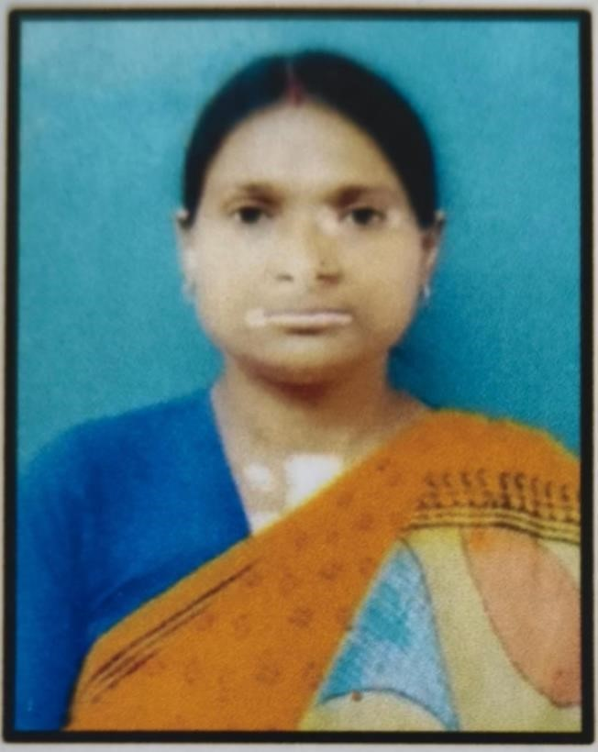

Department : Music

Designation :
SACT

Name :
Sampa

Chakraborty

Date of Joining :
3/12/2013

Experience :
12
years

Mob : 7407619163

Gmail : schakraborty@grsm.ac.in

Parmanent

Address :
Vill
:
-

Konnagar
, City:
-

Ghatal,

Ward no. :
-
14
,
Dist
:
-

Paschim

Medinipur
,

State:
-

West Bengal, Pincode :
-

721212
CURRICULUM VITAE
Teaching Staff
M.A in
Rabindrasangeet

