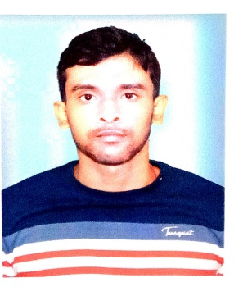 | Name: Dr. Aakash Ranjan Das  Designation: State Aided College Teacher faculty in Sociology  Qualifications: M.A., NET LS., PhD in Sociology  Email & Contact no: ardas@grsm.ac.in & 8250795339

Biographical Sketches

Education:
*PhD in Sociology (2024)- Vidyasagar University, Midnapore (Area of research focus Digitalization and Higher Education, Digital divide, STEM & non-STEM, Gender)

*M.A. in Sociology (2015)- Vidyasagar University, Midnapore

*B.A. (2013)-Department of Sociology, Hijli College under Vidyasagar University, Kharagpur

Awards:
* Awarded the University Gold Medal for achieving first-class first position in Graduation.
* Awarded the University Gold Medal for achieving first-class first position in Post-graduation.
* UGC-NET LS in the year June, 2015

Areas of Specialization & Research
* I am a mixed-method sociologist by training, specializing in education in the context of digitalization, the digital divide, STEM and non-STEM learning communities, gender studies, and the integration of artificial intelligence into academic and research workflows, alongside an emerging area of scholarly inquiry.
* I have also presented my research at numerous seminars and webinars, and have published in a range of national and international journals, served as a reviewer of a reputed International Journal.

Teaching experience

*Guest Lecturer in Sociology at Haldia Law College, Haldia, Purba Medinipur (Nov 2016 to June 2017)

*State Aided College Teacher in Undergraduation Course at the Department of Sociology, Ghatal Rabindra Satabarsiki Mahavidyalaya, Ghatal , Paschim Medinipur (24thJuly 2017 to continue)

Publications

Article published in SCOPUS, UGC-listed &peer-reviewed journals

*Das, A.R., & Bhattacharyya, A. (2021) ‘Smartphone applications in self-coordinated learning practices: A case of Indian peri-urban higher education institution’, Education India: A Quarterly Referred Journal of Dialogues on Education, ISSN 2278-2435.

* Das, A.R., & Bhattacharyya, A. (2022) ‘The cultural lag & digital divide of online learning: An Indian peri-urban region experience’, International Journal of Advance Research and Innovative Ideas in Education, ISSN 2395-4396.

* Das, A.R., & Bhattacharyya, A. (2023) ‘Is STEM a better adaptor than non-STEM groups with online education: An Indian peri-urban experience’, Asian Association of Open Universities Journal, E-ISSN 2414-6994, P-ISSN 1858-3431.

*Das, A.R., & Bhattacharyya, A. (2023) ‘The effects of online classes on learners’ health & quality of life: A survey on an Indian peri-urban higher education institution’, Anwesa Journal of Education, ISSN 0973-5895.

*Das, A.R. (2024) ‘Addressing the gender digital divide in ICT usage in academics: A comparative study of a higher education institution in peri-urban India’, Unisia: Journal of Social Science and Humanities, ISSN 0215-1421 (Print), 2829-1573 (Online).

*Das, A.R. (2025) ‘Digital divide is not a rural issue: A qualitative analysis from the students’ and local people’s perspectives in an Indian metropolitan city’, Anwesa Journal of Education, ISSN 0973-5895.

