- Teachers’ Profile :
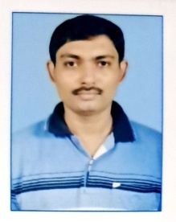
Name Designation and Picture
Arghya Jana , SACT - II

M.Sc.: Botany

Ph.D.:
Specialization:

Ph.D.Title:
Research Experience:
Area of research:
Journal publications:
Seminar/ Conferences /Workshop:

Orientation/refreshers:
Orientation:
Refresher:
Awards/Honours/Membership:

Publications:

